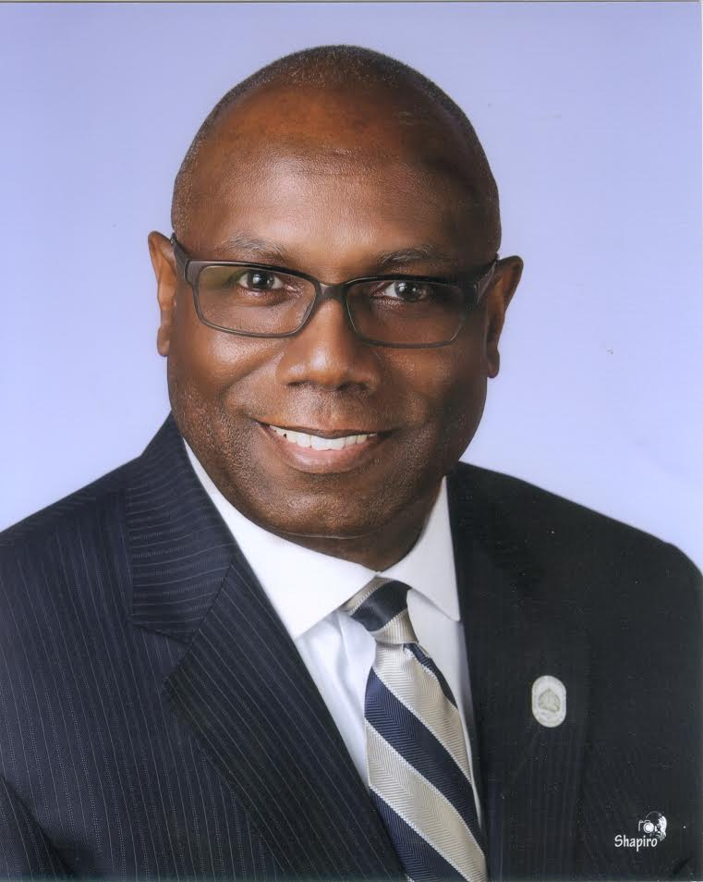

Dr. John O. Herring was born in Newnan, Georgia, and is a graduate of Booker T. Washington High School, Atlanta, Georgia. He received a Bachelor of Science degree from Claflin University, Orangeburg, South Carolina and a Master of Business Administration/Information Systems degree from Brenau University, Gainesville, Georgia. He is also a graduate of California National University, North Hills, California, with a degree in Human Resource Management, graduate of the Johnson Graduate School of Management, Executive Leadership Program, Cornell University, Ithaca, New York, graduate of the U.S. Department of Justice Mediator’s Program, University of South Carolina,

John has been awarded a Doctoral degree in Pastoral Counseling from the Covington Theological Seminary, Rossville, Georgia and Honorary Doctor of Law Degree, Morris Brown College, Atlanta, Georgia. He attended The Governmental Affairs Institute, Georgetown University, Washington, D.C., Graduate, Theology Certificate Program, Interdenominational Theology Center (ITC), Atlanta, Georgia. He is most recently a recipient of a Doctorate of Ministry Degree from the Interdenominational Theology Center (ITC). He is an Associate Pastor at the New Mt. Olive Missionary Baptist Church in LaGrange, Georgia.

Dr. Herring is a published author of a book entitled ***From the Outhouse to God’s House and will be featured in the Interdenominational Center Magazine 2019 Winter Edition.***

Dr. Herring is a retired Lieutenant Colonel of the United States Army where he received numerous awards and decorations. He recently retired a second time as a Regional Manager with the Department of Justice - Alcohol, Tobacco, Firearms and Explosives (Atlanta, Georgia).

Some of Herring’s civilian affiliations include Life membership in the NAACP; Life member Kappa Alpha Psi Fraternity, Incorporated. Additionally, he is a Member of the Board of Trustees at his alma mater, Claflin University, Orangeburg, SC and serves on the Advisory Board with The DeKalb County Magistrate and Misdemeanor Mental Health Court. He was recently appointed to serve the City of South Fulton on the Historic Preservation Society.

He and his wife, Deborah reside in the City of South Fulton. They have two adult children Jia (Dionne McClain), and John O., III. Julian Levi is their grandson who makes life amazing on this portion of their journey! The Herring’s worship and are actively involved in ministry at the Friendship Community Church of College Park, Georgia.